EXPT NO:3 | CLEANSE DATA BY HANDLING MISSING VALUES, OUTLIERS, AND INCONSISTENCIES USING TABLEAU AND POWERBI
DATE: 10.07.2026

PRE-LAB QUESTIONS (PROVIDE BRIEF ANSWERS TO THE FOLLOWING QUESTIONS) :

- What are the potential impacts of missing values in a dataset, and what are some common strategies to address them in Tableau and Power BI?

Missing values can reduce the accuracy of analysis and lead to misleading results. In Tableau and Power BI, they can be handled by removing incomplete records, replacing null values, or filling them using mean or median values.

- What is the importance of identifying and addressing outliers in a dataset? How can outliers affect data analysis and model performance?

Identifying outliers is important because they can distort averages and create misleading trends. Outliers may reduce model accuracy and can sometimes indicate data entry errors or unusual events.

- What types of data inconsistencies might you encounter during data cleansing, and how can Tableau and Power BI help in resolving them?

Data inconsistencies include different spellings, inconsistent date formats, duplicate records, extra spaces, and wrong data types. Tableau and Power BI help resolve these issues through filtering, value replacement, and data transformation tools.

- How do you identify patterns in data using visualizations to spot missing values, outliers, and inconsistencies?
Visualizations help identify missing values, outliers, and inconsistencies by showing chart gaps, unusual spikes, box plot outliers, scatter plot anomalies, and duplicate category labels.

- What is the role of calculated fields in data cleansing, and how can they be used to handle missing values and outliers in Tableau/Power BI?

Calculated fields help clean data by creating new values from existing data without changing the original dataset. They can replace missing values with defaults such as 0 or “Unknown” and identify outliers using conditional logic. This improves data quality and makes analysis and visualization more accurate.

IN-LAB EXERCISE:

OBJECTIVE:
To clean a given dataset (e.g., Superstore Sample in Tableau and Financials/Sales Data in Power BI) by identifying and resolving missing values, outliers, and inconsistencies using built-in tools, ensuring the dataset is accurate and ready for analysis.
PROCEDURE:
  - Open the Tool and Connect Dataset o Open Tableau Desktop , Power BI Desktop.
    - Load the built-in dataset (Sample - Superstore in Tableau / Financials in Power BI).
    - Preview the dataset to understand its structure.
  - Initial Inspection o Explore fields such as Sales, Profit, Region, or Product Category.
    - Check for nulls, inconsistent text values (e.g., "South Region" vs. "South"), or date formatting issues.
  - Handling Missing Values o Use Data Interpreter (Tableau) / Power Query (Power BI) to highlight nulls. o Replace missing numerical values with mean/median, and text with "Unknown".
    - Use calculated fields: IFNULL([Field], Default) in Tableau or IF(ISBLANK([Field]), "Unknown", [Field]) in Power BI.
  - Detecting and Managing Outliers o Create scatter or box plots for Sales and Profit to identify extreme values.
    - Choose strategies:
      - Filter them temporarily.
      - Apply caps using calculated columns.
      - Flag them with labels for review.
  - Resolving Inconsistencies o Use Group/Alias (Tableau) / Replace Values (Power BI) to standardize text.
    - Normalize data formats, such as date fields or currency units.
- Validation with Visuals
    - Build dashboards with histograms, bar charts, and box plots to visually confirm improvements.
    - Compare before/after cleaning stages for accuracy.
- Save the Cleaned Dataset o Save as .twbx (Tableau) / .pbix (Power BI).
o Optionally export cleaned data to .csv.
- Summary Dashboard
o Create a visual summary of the cleaning process, highlighting:
      - Fields corrected.
      - Nulls/outliers removed or adjusted.
      - Clean dataset metrics (record count, completeness %).

Experiment Dataset:
  - Tableau: Sample - Superstore
  - Power BI: Financials or Sales Data
How to Access:
Tableau:
  - Navigate to: Start Page → Sample Workbooks
  - Or: Help → Sample Data → Open Sample Data Folder
Power BI:
  - Navigate to: Home → Get Data → Excel → Choose sample datasets (e.g., Financial Sample.xlsx)
  - Microsoft also hosts Power BI sample datasets online.
Fields Used:
  - Sales
  - Profit
  - Region
  - Category
  - Order Date / Transaction Date

TABLEAU DASHBOARD:
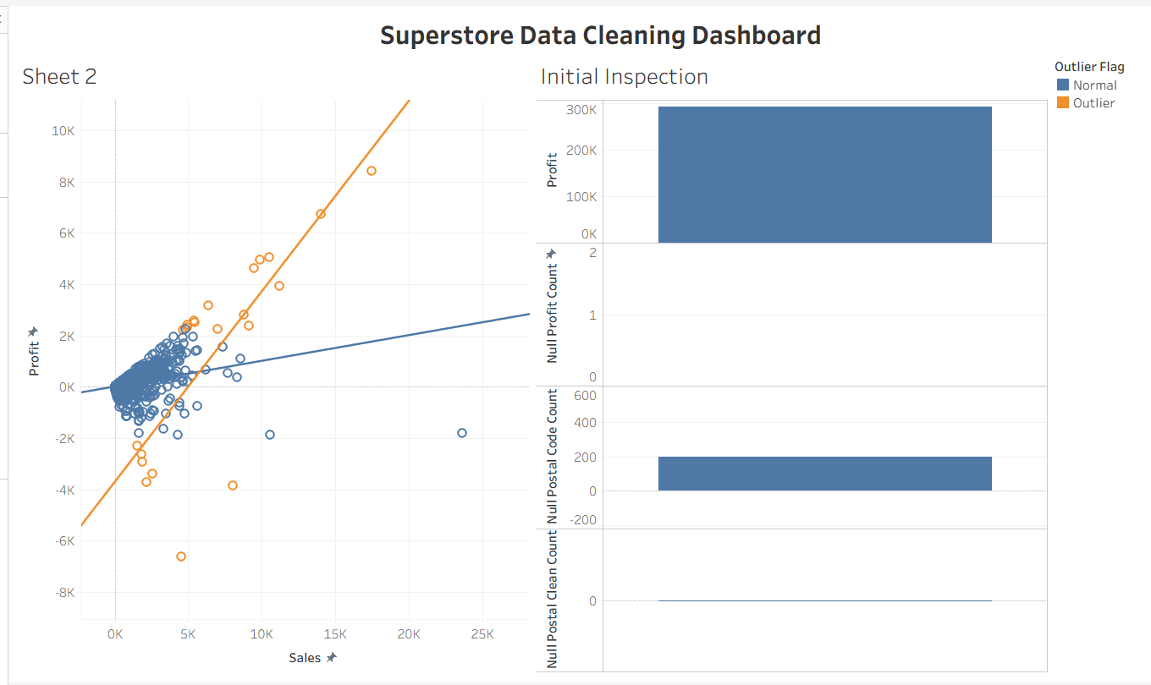

POWER BI DASHBOARD :

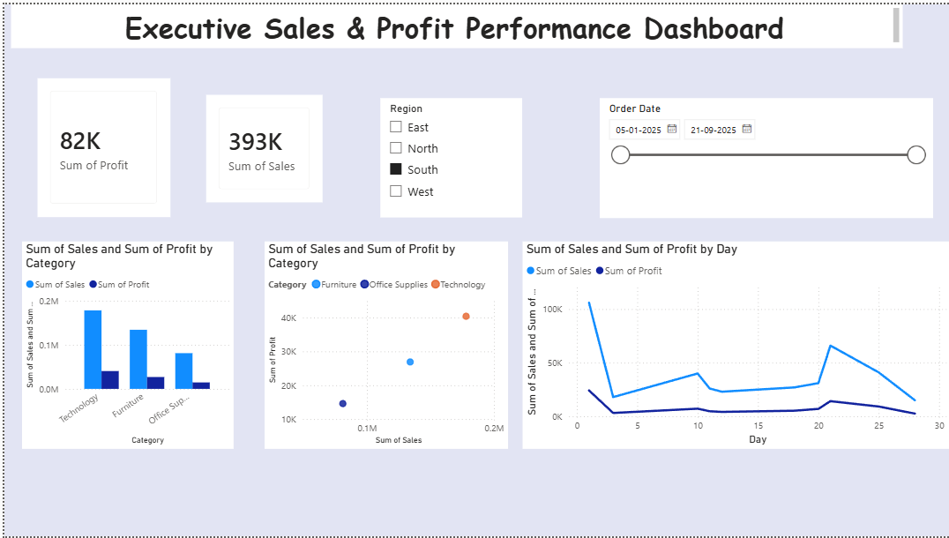

POST-LAB QUESTIONS (PROVIDE BRIEF ANSWERS TO THE FOLLOWING QUESTIONS)
- What method did you use to replace missing values in numeric fields?

Missing values in numeric fields were replaced using the mean or median method. This helped maintain the overall data distribution and prevented the loss of important records. The method ensured that the dataset remained complete for analysis. As a result, the data became more reliable and suitable for visualization.

- How were outliers handled in your dataset and what visual confirmed their correction?

Outliers were identified through visual analysis using charts and statistical methods. They were handled by removing or capping extreme values within the normal range. A box plot was used to confirm their correction after cleaning. The reduction of abnormal points indicated that the dataset had become more consistent.

- What inconsistencies were detected in categorical values and how were they standardized?

Inconsistencies such as different spellings, extra spaces, and varied text formats were detected in categorical values. These issues were standardized by trimming spaces and correcting spelling variations. Values were also converted into a uniform format for consistency. This improved the accuracy of grouping and filtering in the analysis.

- Describe how calculated fields helped in resolving data issues.

Calculated fields helped resolve data issues by replacing missing values automatically. They were also used to identify and flag outliers based on specific conditions. In addition, calculated fields standardized inconsistent values and created cleaner columns. This made the dataset more accurate and easier to analyze.

- How did your dashboard demonstrate the effectiveness of the data cleaning process?

The dashboard demonstrated the effectiveness of data cleaning through clearer and more consistent visualizations. Outliers and missing values were significantly reduced after the cleaning process. Standardized categories made the charts more organized and easier to interpret. Overall, the dashboard reflected improved data quality and more accurate analysis results.

RESULT:

The dataset was successfully cleaned and prepared for accurate analysis using Tableau and Power BI. Issues such as nulls, inconsistencies, and outliers were identified and resolved, improving data quality significantly.

ASSESSMENT

Description |  | Max Marks | Marks Awarded
Pre Lab Exercise |  | 5
In Lab Exercise |  | 10
Post Lab Exercise |  | 5
Viva |  | 10
 | Total | 30
 |  | Faculty Signature

